Device.com: How to Compile

1. Open DeviceWebApi.sln and run the program
2. Ensure that address is <http://localhost:5000/> like in the photo below
3. If localhost port number is not like above, open a cmd prompt in Devices Folder 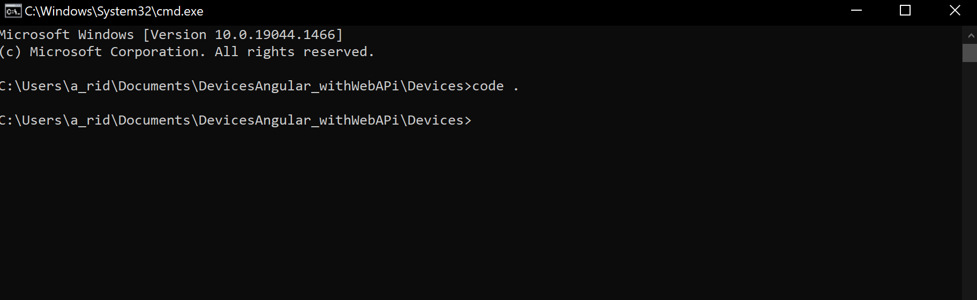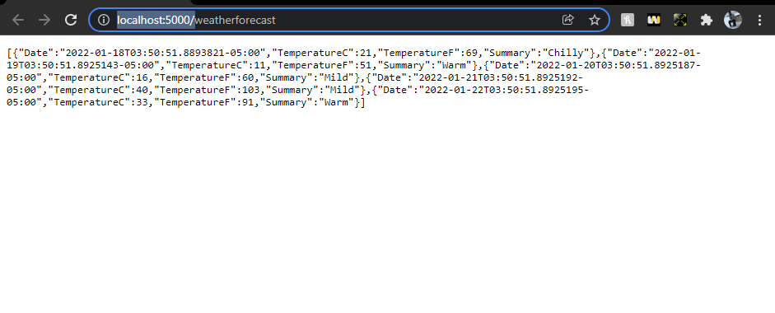
4. This will open up the vs code project, go to shared.service.ts and change port number in the APIUrl and PhotoUrl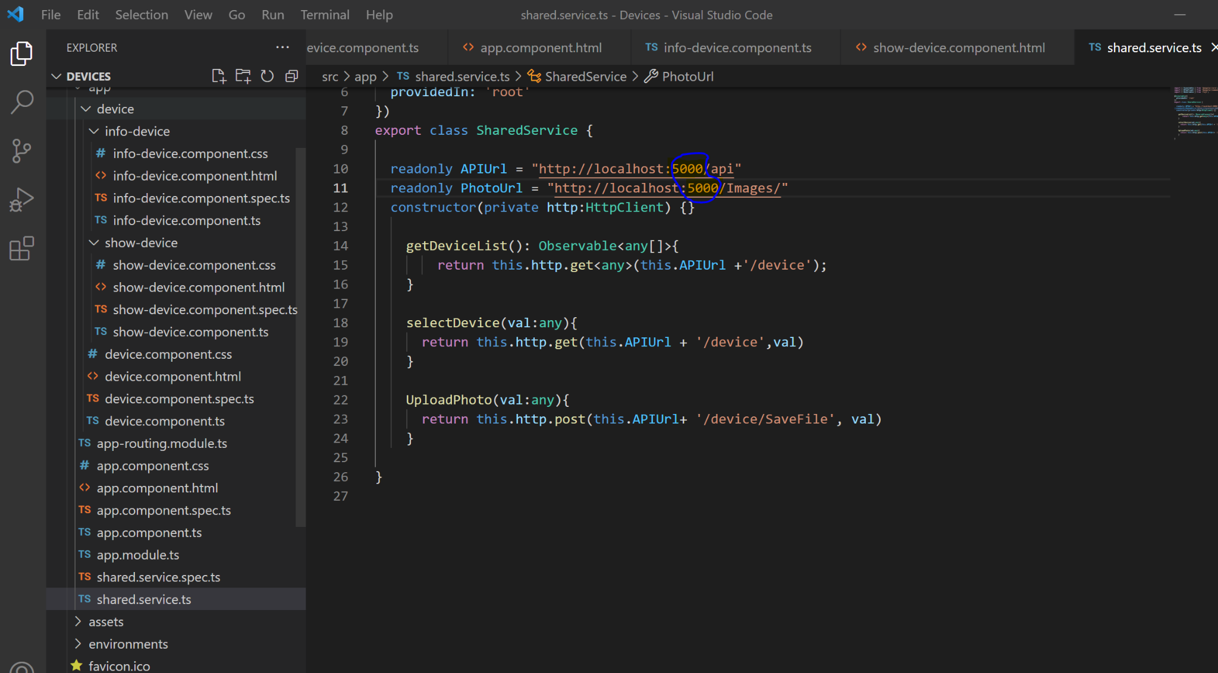
5. Now in the cmd prompt in the device folder directory type in ng serve and it will comply the project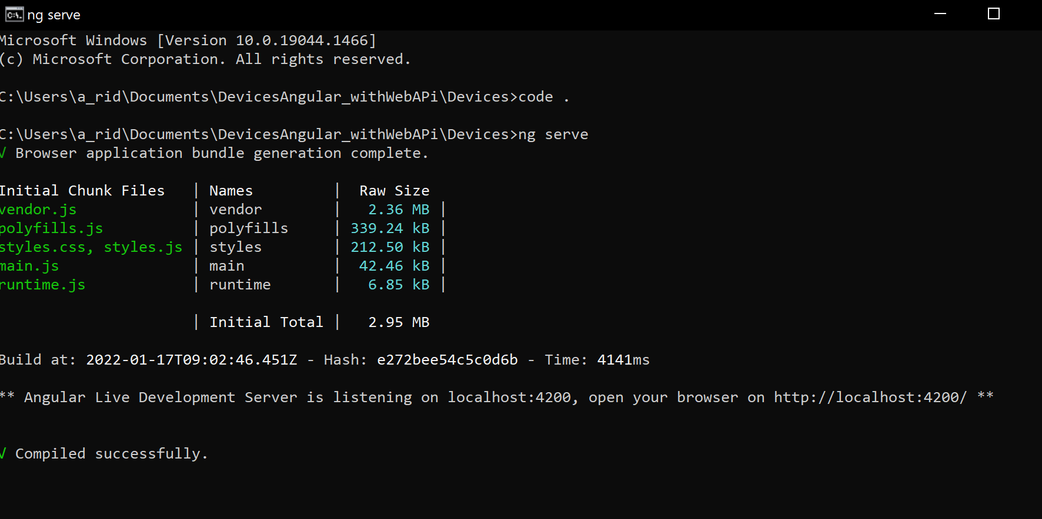
6. Now that the program has compiled type in localhost:4200/device into a browser and you will see the angular project

